Existing Agreement Change Via Upload:
The document Elaborates the process of Existing agreement Change in Vistex application via Upload.
Required setup:
Master Agreement must be created by upload / Manually. The respective Request number should be noted. Ex: 1051 (in quality system)

Areas Supported as part of Change
- Inside Flexible group – Category Inclusion & Exclusion.
- To Add new Sub agreement to Existing Master agreement

Exercise 1: Creation of Agreement via Upload/ Manually.
- Agreement must be created manually or through Upload.
- Note the request number of Master Agreement created. (ex: 1051)
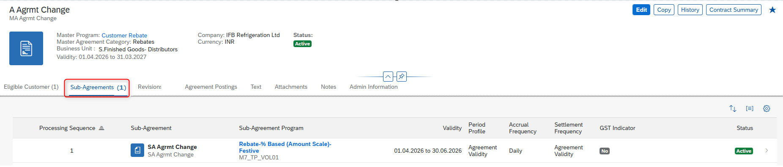

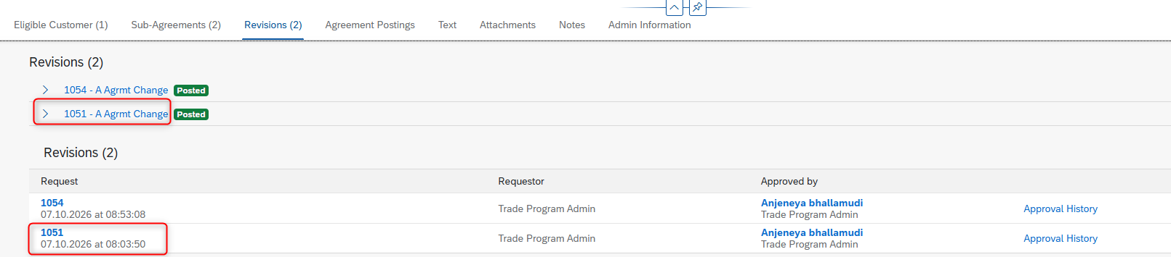

Exercise 2: Download The Request for Flexible Group Number:
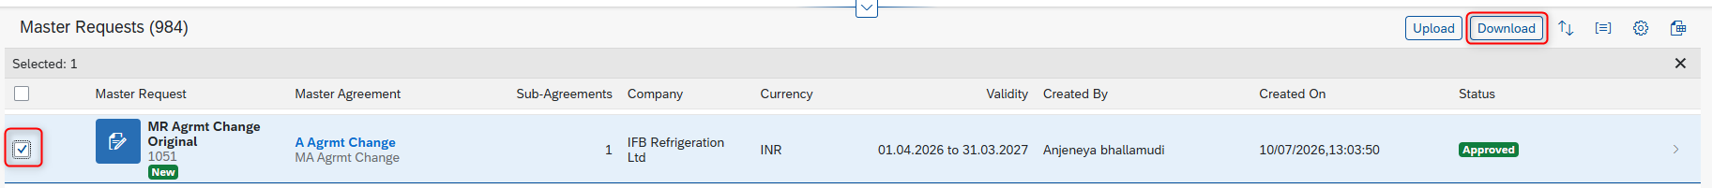
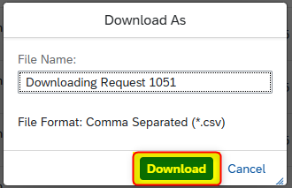
The request must be downloaded, to get the flexible group number and other required data.
In Downloaded File:
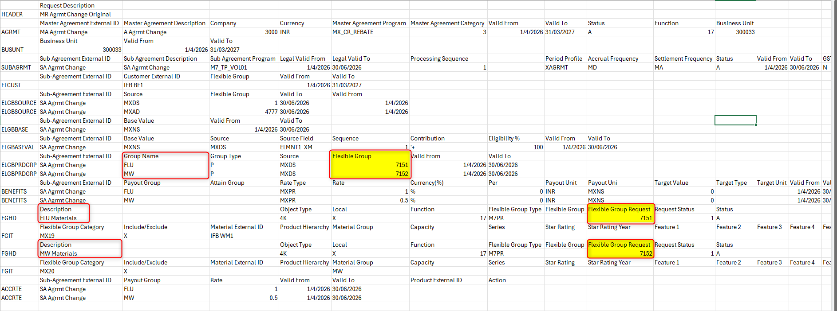
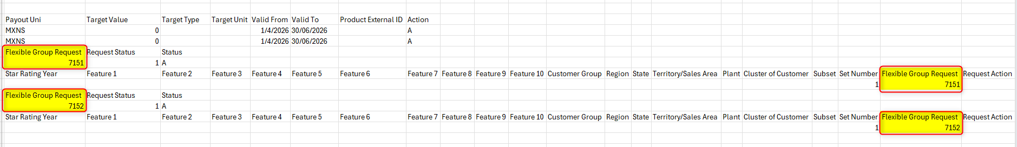

Explanation:
During Upload, for flexible group creation we need to give New1, New2.
As soon as upload is completed, New 1 and New 2 will be allocated a system generated number.
The respective system generated number is required to change/ add data to existing flexible groups.
By downloading requests, we can get flexible group numbers.

Exercise 3: To Prepare Change Upload File and Upload.
Like upload, two different variants are provided for Amount & Quantity Programs.
Variant List:
- Rebate - %Based (Amount Scale)_Change – For Amount Programs
- Rebate - %Based (Quantity Scale)_Change – For Quantity Programs
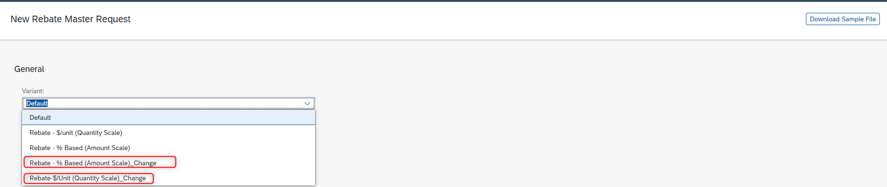
The sample file of each variant can be downloaded using Download sample file button after selecting required variant.
Note: The data as to be maintained for required action only.

File preparation:
The file must be prepared based on the user required changes to be made in existing agreement. The file must be uploaded using above highlighted/mentioned variants.
Ex: For mentioned example, two changes are made to existing Master agreement.
Change 1: In Flexible groups, materials are added for Including and Excluding.
Action Field Data:
It has 2 values – Add (A), Change (C)
The required changes in files are highlighted in blue color in the screenshot below
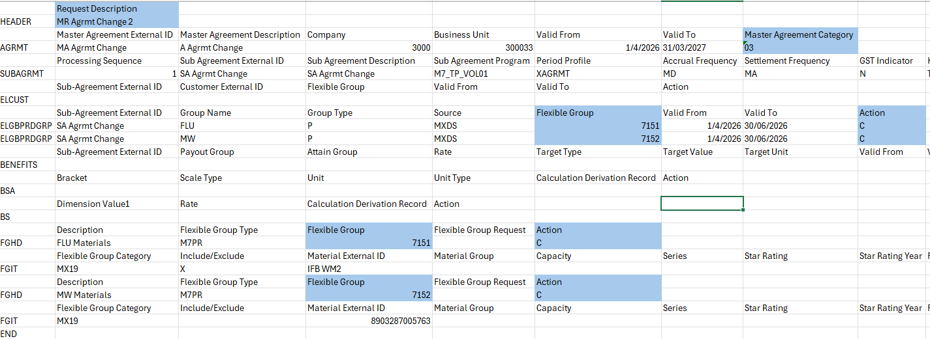
Change 2: Addition of New Sub agreement for existing Master Agreement
The process remains same for new sub agreement creation as previous uploads using Change variants files.
The flexible group must be maintained New1 and New2.
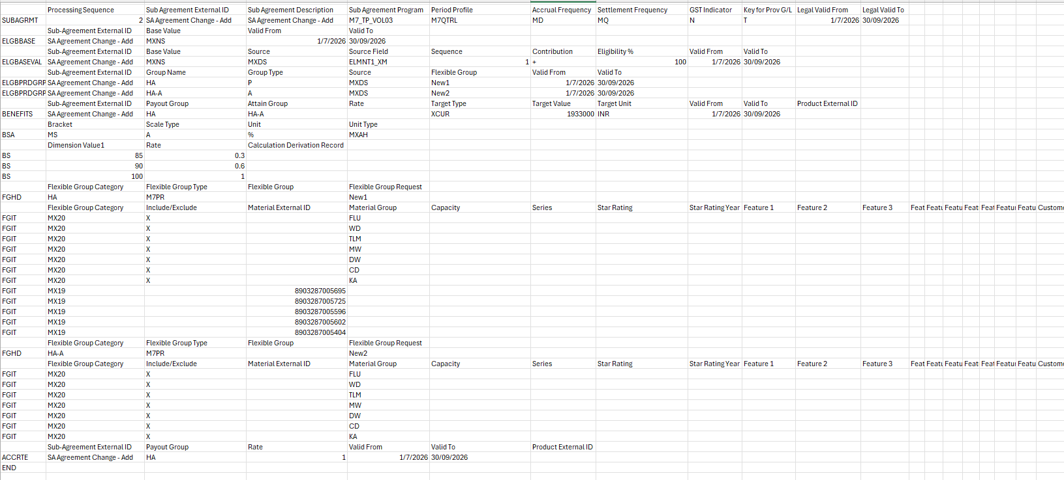

Change template
Example
Amount
